**Quarterly Report – Public Page**

**Date of Report:** 4th Quarterly Report - *October 2, 2023*

**Contract Number:** *693JK32210015POTA*

**Prepared for:** *DOT-PHMSA*

**Project Title:** *Dynamic Geohazard Risk and Decision Support Platform*

**Prepared by:**  *Boston Geospatial, Inc.*

**Contact Information:**  *Justin Oliveira,* [*justin@bostongeospatial.com*](mailto:justin@bostongeospatial.com)*, 321-720-3568*

**For quarterly period ending:** *September 30, 2023*

**1: Items Completed During this Quarterly Period:**

A detailed overview of the progress this past quarter is provided in the various sections below.

| ***Item #*** | ***Task #*** | ***Activity/Deliverable*** | ***Title*** |
| --- | --- | --- | --- |
| 10 | 3.1 | Geohazards Module | Modify existing internal seismic event API; Consolidate fault line data and initialize geodatabase |
| 8 | 5.1 | Cost Estimation Module | Research and create rehabilitation cost estimation framework |
| 12 | 0.1 | 4th Quarterly Status Report | Submit 4th quarterly report |

**2: Items Not-Completed During this Quarterly Period:**

| ***Item #*** | ***Task #*** | ***Activity/Deliverable*** | ***Title*** |
| --- | --- | --- | --- |
| 11 | 5.2 | Cost Estimation Module | Research and create replacement/triage cost estimation framework; Cost estimation report generator module development |

**3: Project Financial Tracking During this Quarterly Period:**

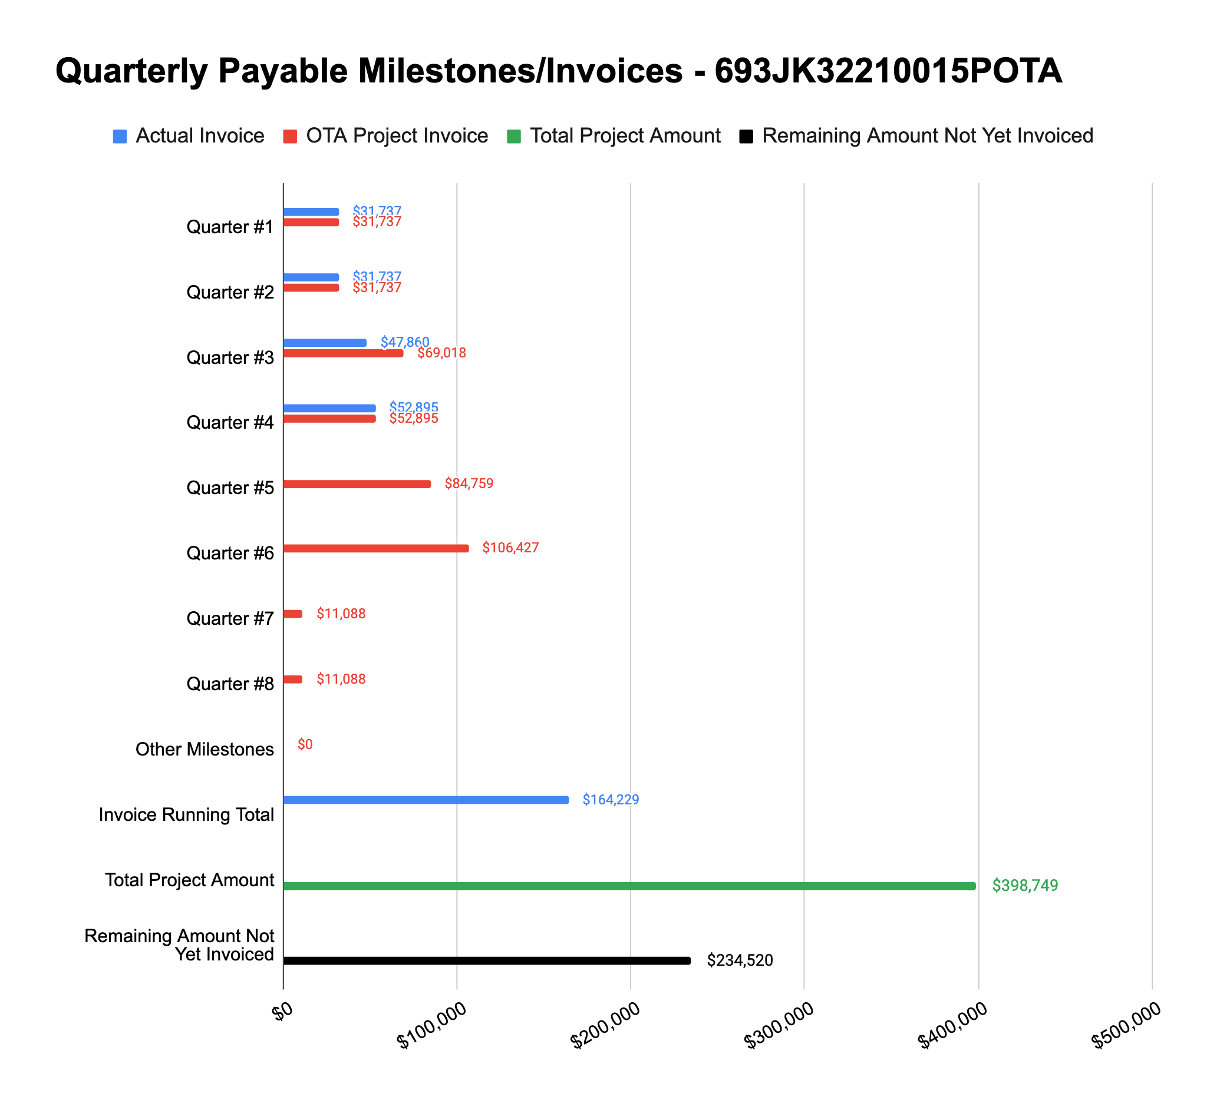

**4: Project Technical Status –**

**Item# 10 / Task# 3.1/ Geohazards Module / Modify existing internal seismic event API; Consolidate fault line data and initialize geodatabase**

Over the past quarter we have consolidated and cleaned up publicly available fault line data as well as initialized the data in a geodatabase - this information will be used in the generation of the load cases (if a pipe crosses an active fault). We have also modified an existing internal seismic dataset and API function for use in the Geohazard Module. Functionality includes the ability to query the seismograph database for past (historical) events as well as near real-time events.

The previously developed load and stress equations for seismic require a peak ground velocity (PGV) as well as soil parameters to compute the associated strain. To evaluate this, we have leveraged our existing seismic event API (which retrieves and filters the FDSN catalog) as well as the USGS/ASCE7 API - the latter of which provides seismic design parameters following ASCE7 using the USGS risk model[1]. First we retrieve the last century of events from FDSN and, using the CDI, we calculate the peak ground acceleration (PGA) using the Worden[2] model and then, using the distance to pipe segment distance, we estimate the PGV for all the historical events. In parallel, we retrieve the design mean PGA from the USGS/ASCE7 API and from it we estimate the PGV using the mean moment magnitude and distance from the historical events - largely stemming from nearby faults. A comparison of the USGS/ASCE7 PGV with the 100-year event average PGV is performed, and if a flag is set the function will use the most conservative of the two values. This function will be documented in detail in the Geohazards API and Methodology Documentation later in the project.

**Item# 8 / Task# 5.1/ Cost Estimation Module / Research and create rehabilitation cost estimation framework**

We have completed the three work streams related to the completion of this task: (i) algorithm flowchart directing the tool to develop triage, rehabilitation, and/or replacement options; (ii) algorithm flowchart for performing of stress/margin sensitivity analysis to backfill parameter; and (iii) algorithm flowchart for cost estimation for backfill re-engineering. We added support for Monte Carlo-based sensitivity analysis to the tool - this allows for quantifying the sensitivity any and all variables have in the model for any calculated value (including stress margins).

The algorithm flowchart for cost estimation for backfill re-engineering was developed using a bottoms-up approach, which we have compared to verbal estimate ranges ($50k-$250k per site) from pipeline integrity SMEs who have done many of these types of digging operations in the past. The algorithm takes into account the pipe segment location, proximity to roads, slope and land cover conditions, etc. Cost metrics associated with earth work, right-of-way clearing, trench work, etc. were taken from publicly available data and translated to current-year dollars using CPI data from BLS[3]. An editable source file will be included with the tool that will allow customization of these figures by operator end-users based on their own datasets if they don’t want to use the default values. We believe this bottoms-up approach to be the best avenue and will seek to calibrate it further with operator-provided data as a future improvement effort to the tool. This algorithm will be documented in detail in the Costing API and Methodology Documentation later in the project.

**Item# 11 / Task# 5.2/ Cost Estimation Module / Research and create replacement/triage cost estimation framework; Cost estimation report generator module development**

Progress on researching and developing a framework to estimate pipe replacement and triage costs has been delayed due to the need to develop a bottoms-up framework for Task 5.1. However there is more literature available for these cost estimating activities (compared to the backfill re-engineering activity tackled in Task 5.1). The replacement cost algorithm builds off the work done in the backfill re-engineering methodology but also includes cost factors for pipe material and welding developed by the Pacific Northwest National Laboratory[4], which are also translated to current-year dollars using CPI data. The remaining work for this task involves merging all efforts under Task Area 5 to create both a report template and the corresponding code to generate the reports based on the load case and stress margin calculations - this work should be complete over the next several weeks. This algorithm, as well as the previously mentioned cost methodologies and algorithms, will be documented in detail in the Costing API and Methodology Documentation later in the project.

**Item# 12 / Task# 0.1/ 4th Quarterly Status Report / Submit 4th quarterly report**

Additional detail not necessary - this report constitutes the deliverable for Item# 12 / Task# 0.1. We plan to complete the work associated with Task 5.2 and issue a revision to this 4th Quarterly Status Report.

**5: Project Schedule –**

Overall our project is about 2-3 weeks behind schedule - since our last update, this gap has been slightly improving as we have completed most of the higher risk work around the Cost Estimating Module. We are ahead of schedule already on upcoming tasks, so we anticipate being able to make up some time there.

1. https://earthquake.usgs.gov/ws/designmaps/asce7-22.html
2. https://pubs.geoscienceworld.org/ssa/bssa/article-abstract/102/1/204/349630/Probabilistic-Relationships-between-Ground-Motion?redirectedFrom=fulltext
3. https://www.bls.gov/cpi/data.htm
4. https://www.researchgate.net/publication/236421832_National_Lab_Uses_OGJ_Data_to_Develop_Cost_Equations/link/551d9f360cf29dcabb030e5a/download